ARIGNAR ANNA GOVERNMMENT ARTS AND SCIENCE COLLEGE MUSIRI-621 211

Department of Physics

Title:Politiical Juggernauts:A Quantitative Analysis of Candidates in the 2019 Lok Sabha Elections

Team members:

1. R.Mahalakshmi (B835DB795181E81AF404B3AFBEAAB840)
2. N.Megala (DBD23D071226336AB51405B4DA8710D9)
3. R.Monisha (1121B0DA7D1B4C5868A4FE6B3F1890A7)
4. N.Naveen (06D72D72FEA867581574AD1783A98750)

INTRODUCTION:

The Lok Sabha is composed of representatives of people chosen by direct election on the basis of Universal Adult Suffrage. The Constitution of India allows for a maximum of 550 members in the House, with 530 members representing the States and 20 representing the Union Territories. The 17th Lok Sabha was formed by the members elected in the 2019 Indian general election. Elections, all across India, were conducted in seven phases from 11 April 2019 to 19 May 2019 by the Election Commission of India.

The Bharatiya Janata Party received 37.36% of the vote, the highest vote share by a political party since the 1989 general election, and won 303 seats, further increasing its substantial majority. In addition, the BJP-led National Democratic Alliance (NDA) won 353 seats.

Milestone 1;

1: Define Problem / Problem Understanding

Activity 1: Specify the business problem

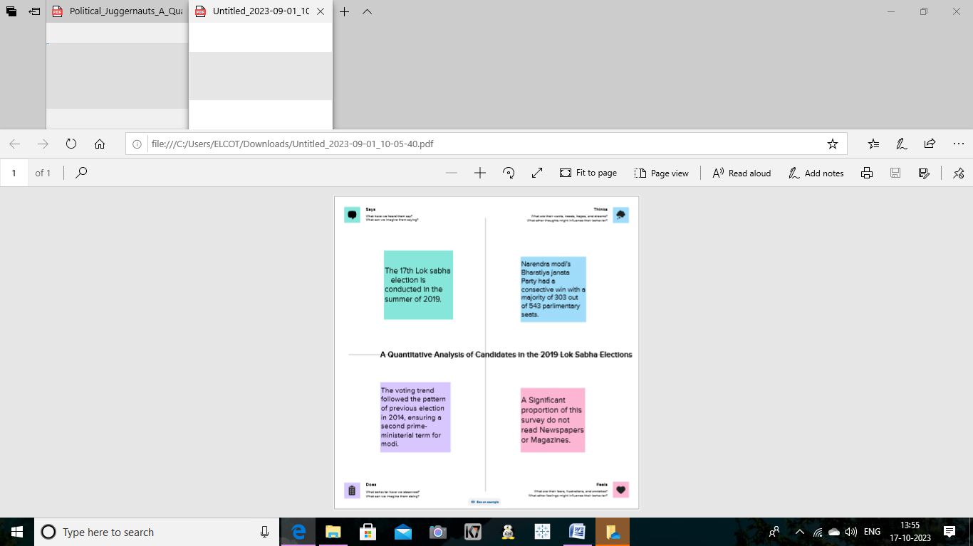Activity 2: Requirements

The Requirement is to analyse the winners and total voters and electors and Postal Votes of Lok Sabha, and criminal Cases in Each State & Party. In which State There are more winners and which party got more seats and liabilities and assets of each state. For this Created KPI’s and interactive Visualizations and Dashboard and story Board to bring clean and deep understanding

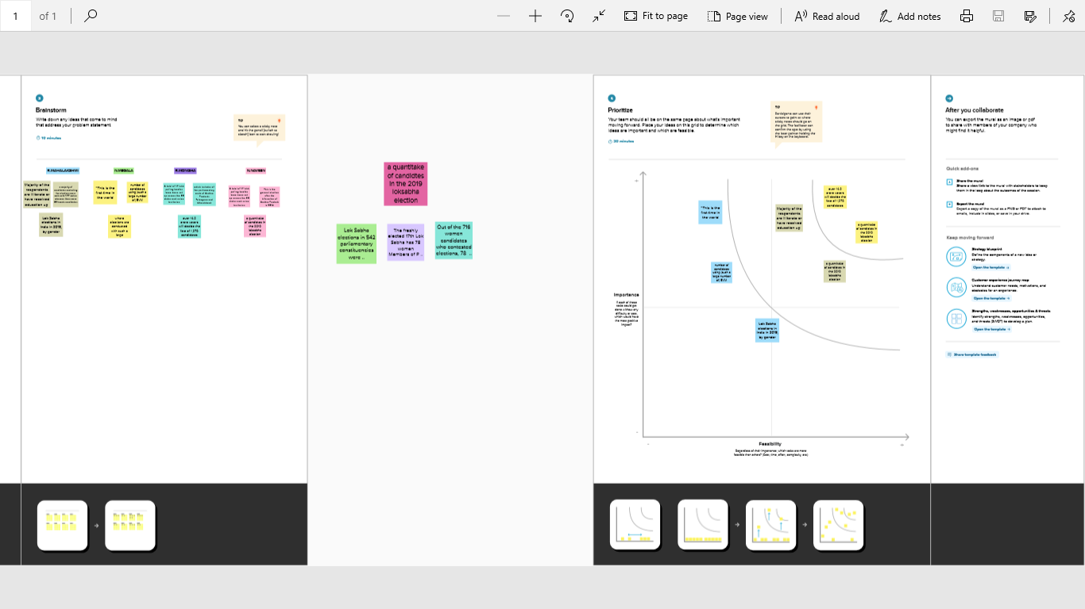

Milestone 2: Data Collection & Extraction

Data collection is the process of gathering and measuring information on variables of interest, in an established systematic fashion that enables one to answer stated research questions, test hypotheses, and evaluate outcomes and generate insights from the data.

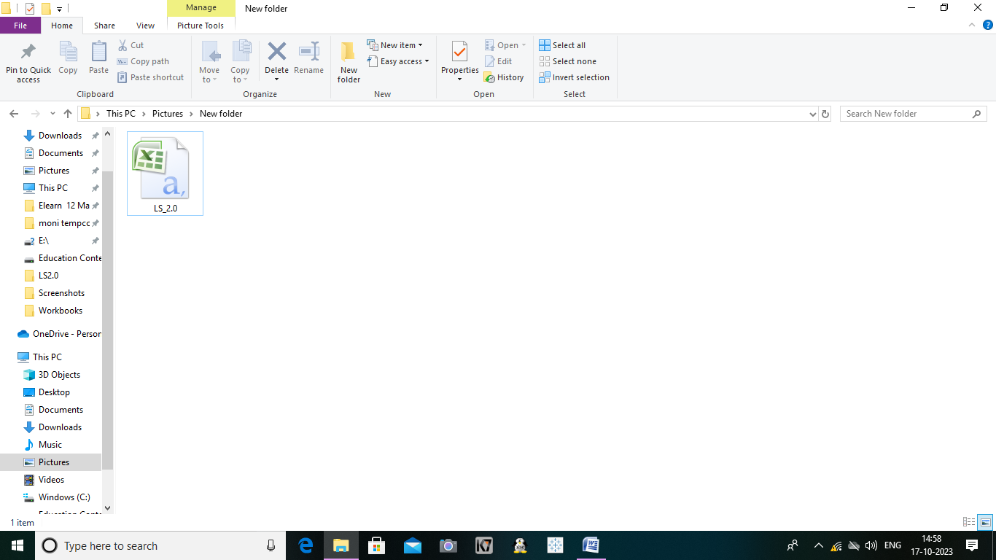

ACTIVITY 2: Connect The Dataset with tableau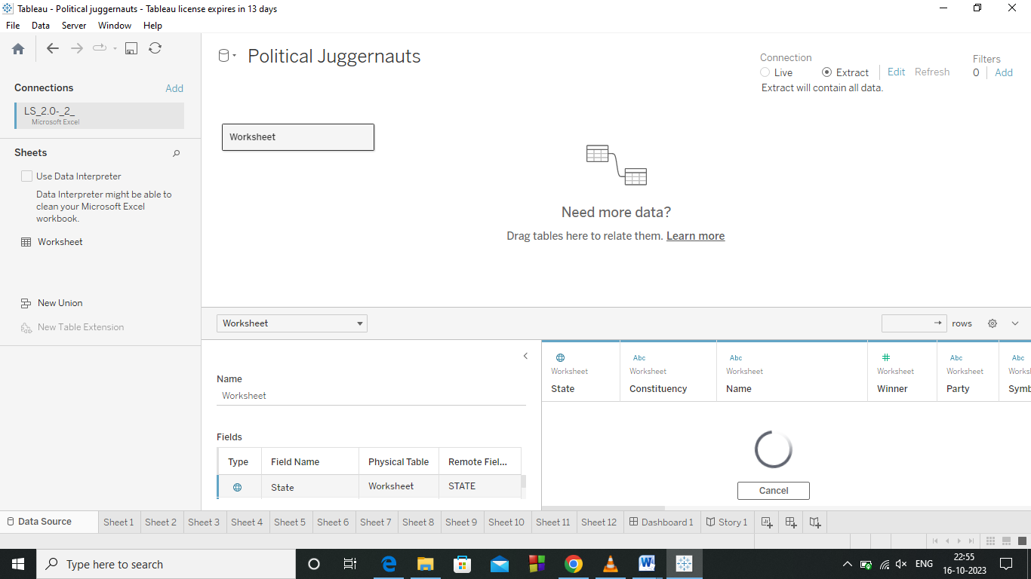

Milestone 3: Data Preparation

Activity 1: Prepare the Data for Visualization

Preparing the data for visualization involves cleaning the data to remove irrelevant or missing data, transforming the data into a format that can be easily visualized, exploring the data to identify patterns and trends, filtering the data to focus on specific subsets of data, preparing the data for visualization software, and ensuring the data is accurate and complete. This process helps to make the data easily understandable and ready for creating visualizations to gain insights into our analysis.

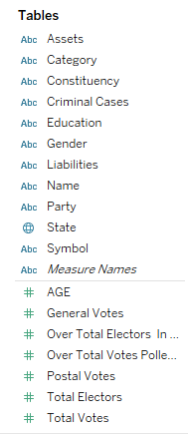

Milestone 4: Data Visualization

Data visualization is the process of creating graphical representations of data in order to help people understand and explore the information. The goal of data visualization is to make complex data sets more accessible, intuitive, and easier to interpret. By using visual elements such as charts, graphs, and maps, data visualizations can help people quickly identify patterns, trends, and outliers in the data

Activity 1.1: KPI’s

<https://drive.google.com/file/d/18uRL_LX1gLDwjZYLKINJZUAXj5mbzgS/view?usp=drive_link>

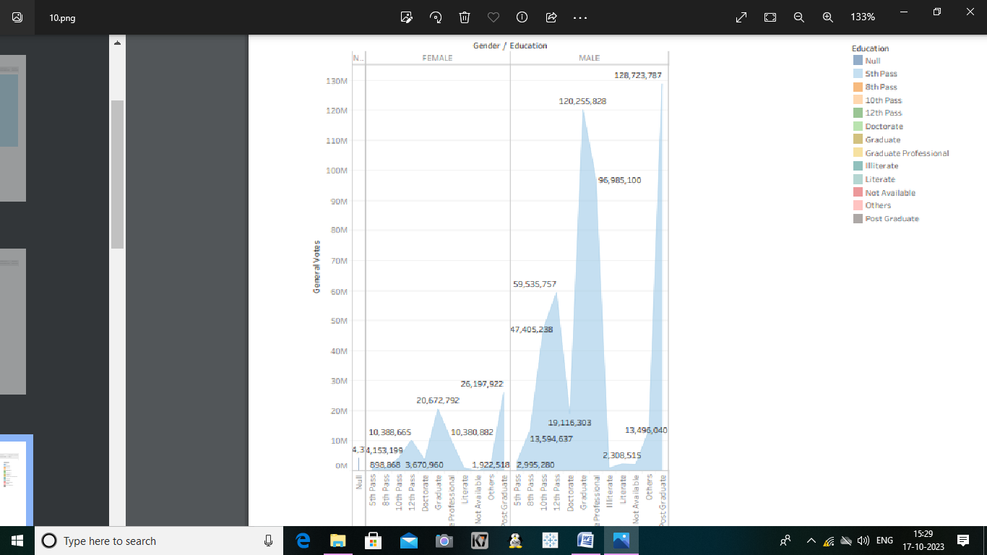

Activity 1.2: Gender & educational Wise General Votes.

https://drive.google.com/file/d/1i5S454mBe6PnHUenjl6VBeuMg8cnpFkt/vie w?usp=drive_link

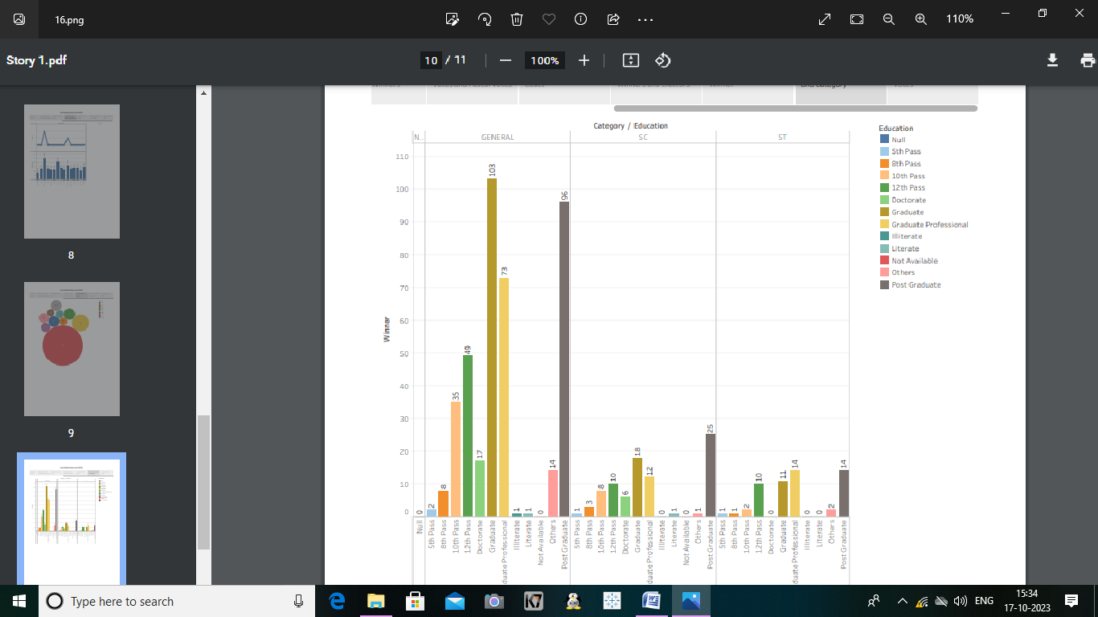

Activity 1.3: State wise Winner.

https://drive.google.com/file/d/1UD6q4_umssIg3O7fdeqGr86OQpPOQ9uh/v iew?usp=drive_link

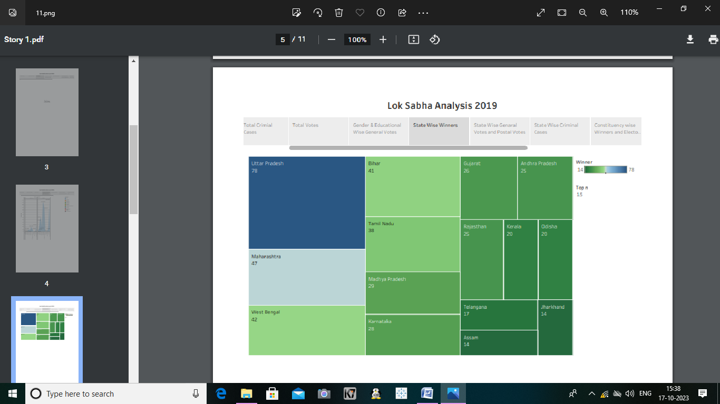

Activity 1.4: State wise General Votes and Postal Votes.

https://drive.google.com/file/d/1yOvqqJI7bImH_JQSlSClFqeFFFIfmrcX/view? usp=drive_link

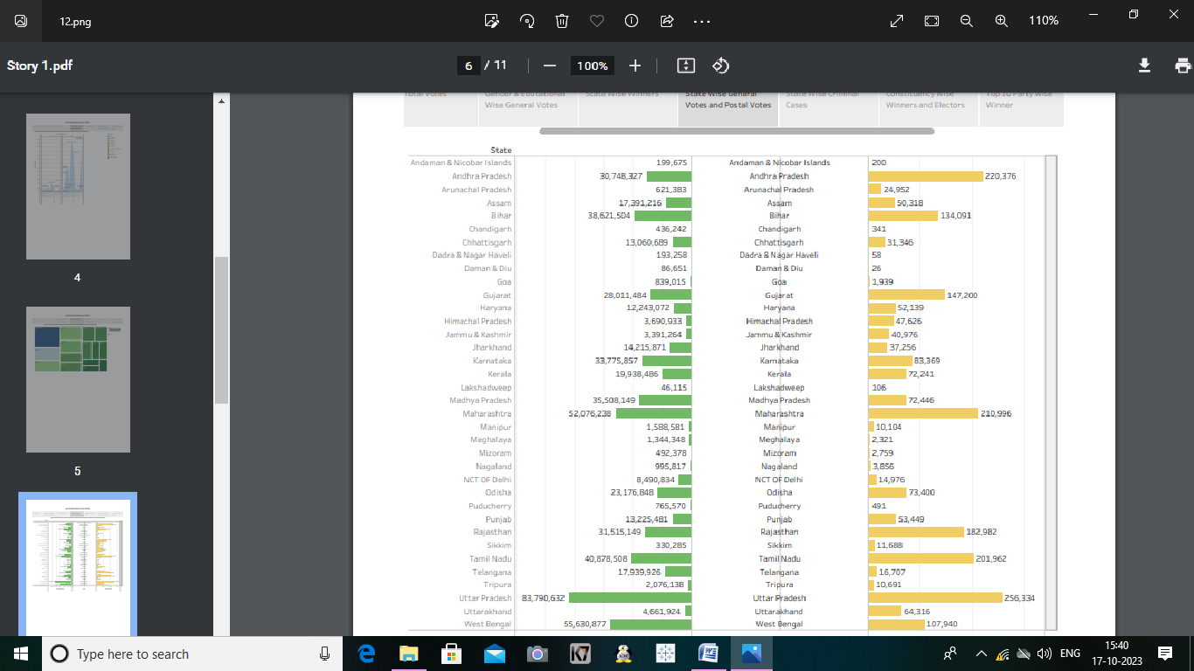 Activity 1.5: State wise Criminal Cases.

https://drive.google.com/file/d/1Zj4jb9TcI7vTB_k1Vj55zGMh_cejZMAY/view ?usp=drive_link

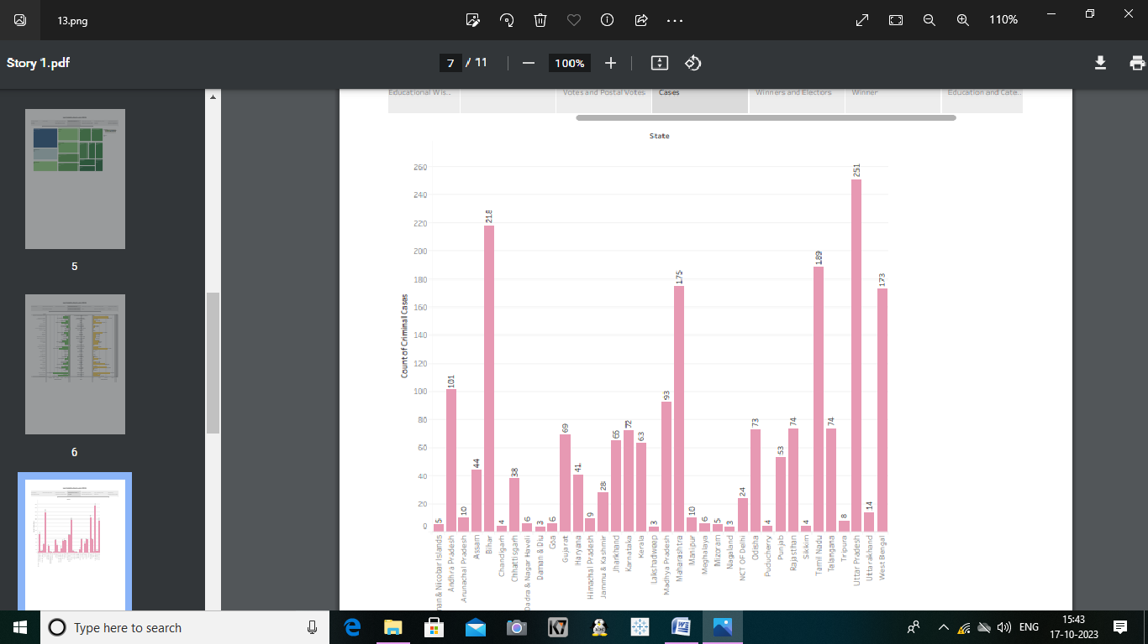

Activity 1.6: constituency wise Winners and Electors

https://drive.google.com/file/d/1MkY0K9btwRLnUK6RhGOqxwGMZfcjXDJc/ view?usp=drive_link

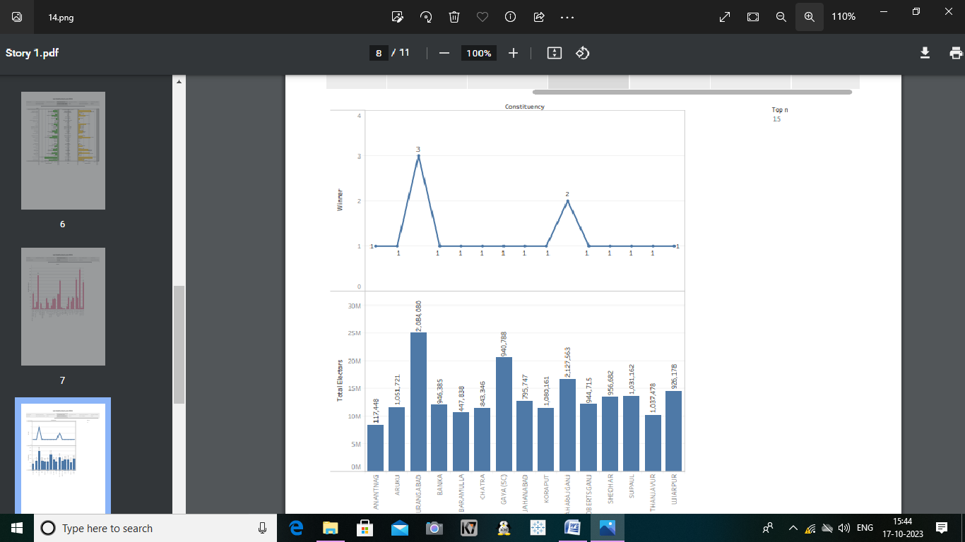

Activity 1.7: Party wise Winner.

https://drive.google.com/file/d/1zLsSkKb428XwdtByOJwwBEAgOK3D0uvT/v iew?usp=drive_link

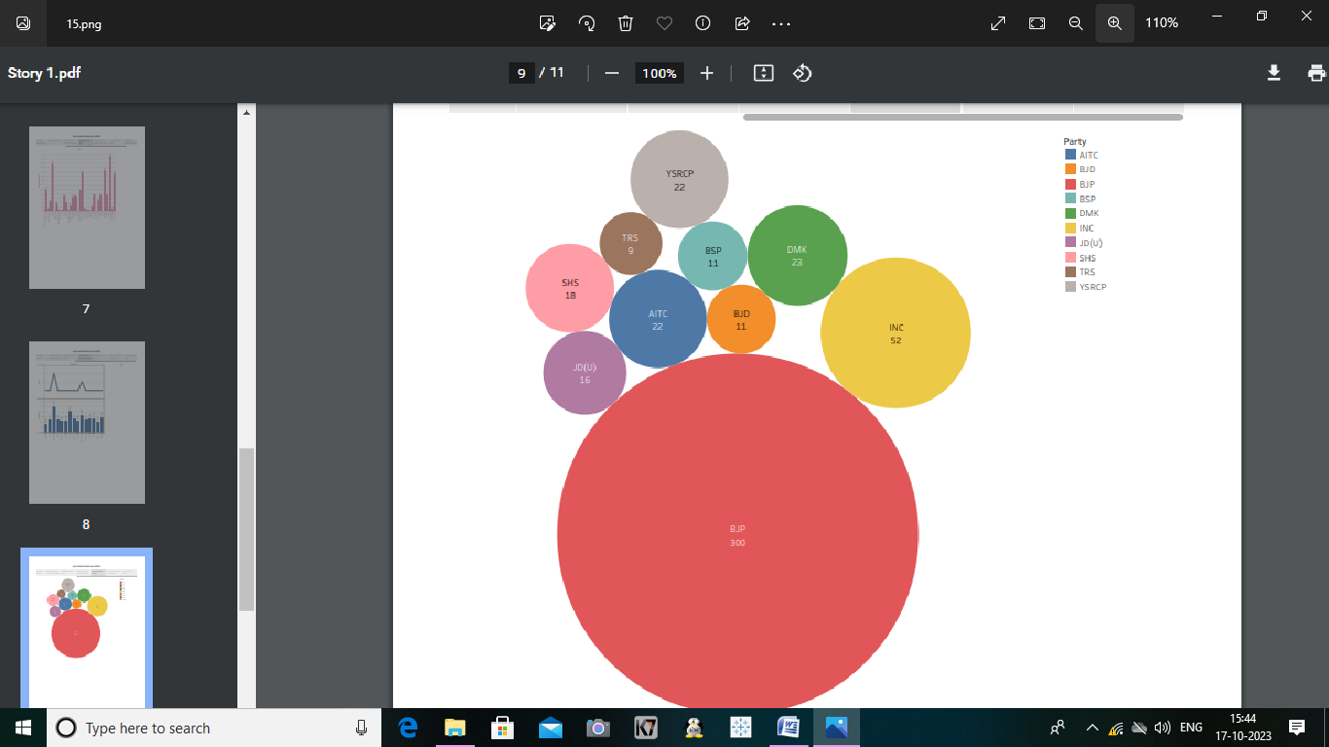

Activity 1.8: Winners by Education and Category.

https://drive.google.com/file/d/1EuWwqEQs51xa9ST7366O-JlzeZMgMmV/view?usp=drive_link

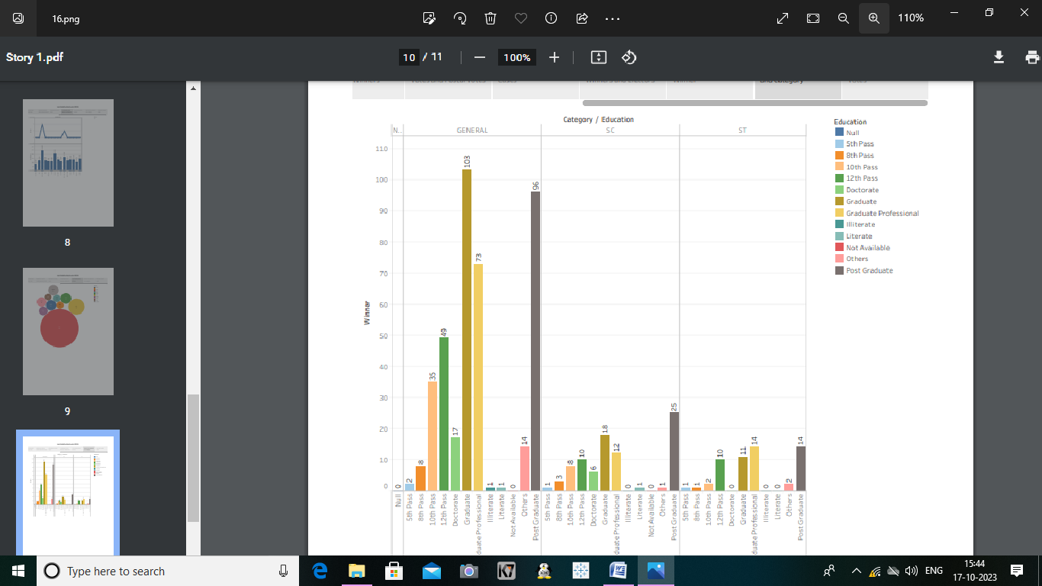

Activity 1.9: Party Wise Postal Votes

https://drive.google.com/file/d/1HOKSVMRq62MqXZm1wV7ZWXY5BOf88Ih/view?usp=drive_link

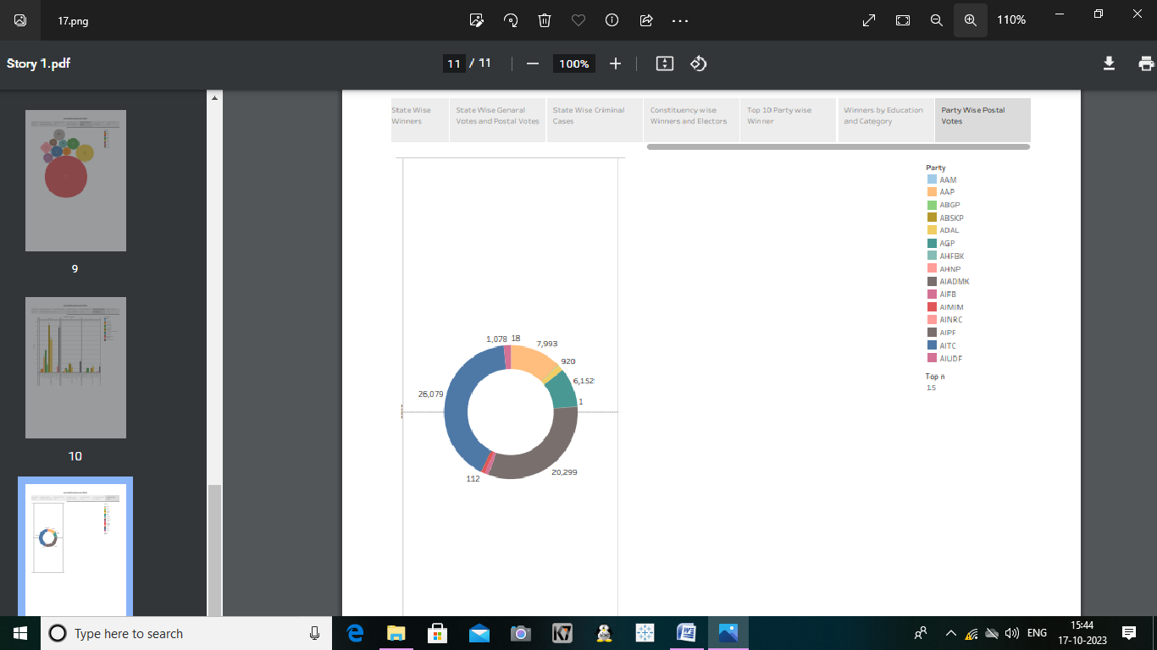

Milestone 5: Dashboard

A dashboard is a graphical user interface (GUI) that displays information and data in an organized, easy-to-read format. Dashboards are often used to provide real-time monitoring and analysis of data, and are typically designed for a specific purpose or use case. Dashboards can be used in a variety of settings, such as business, finance, manufacturing, healthcare, and many other industries. They can be used to track key performance indicators (KPIs), monitor performance metrics, and display data in the form of charts, graphs, and tables.

Activity :1- Responsive and Design of Dashboard.

Once you have created views on different sheets in Tableau, you can pull them into a dashboard.

Explanation Video: <https://public.tableau.com/app/profile/mahalakshmi.mahalakshmi/viz/Book1_16962483958560/Dashboard1?publish=yes>

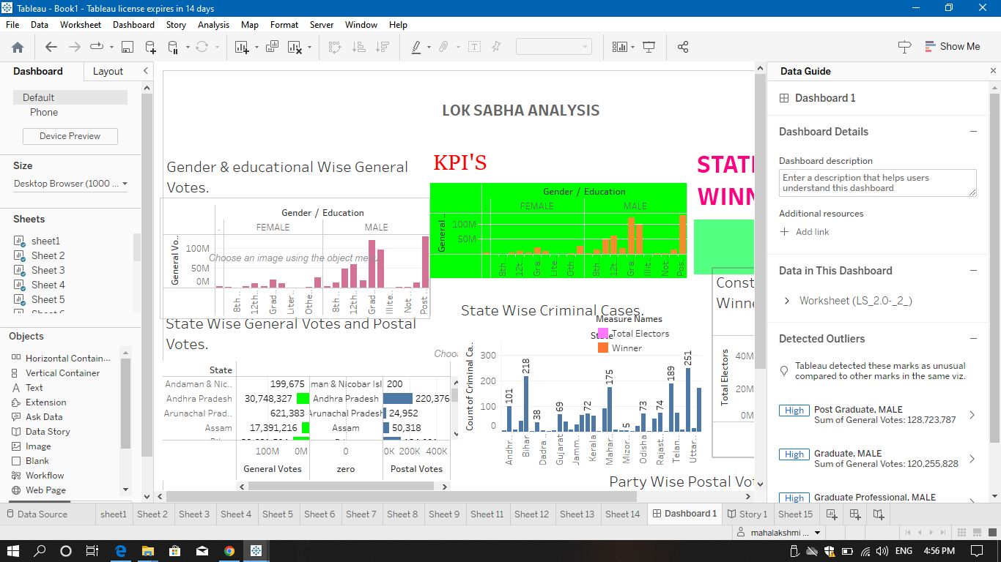

Milestone 6: Story

A data story is a way of presenting data and analysis in a narrative format, with the goal of making the information more engaging and easier to understand. A data story typically includes a clear introduction that sets the stage and explains the context for the data, a body that presents the data and analysis in a logical and systematic way, and a conclusion that summarizes the key findings and highlights their implications. Data stories can be told using a variety of mediums, such as reports, presentations, interactive visualizations, and videos

Activity:1- No of Scenes of Story







MILESTONE :PUBLISHING

Dashboard;1

<https://public.tableau.com/app/profile/mahalakshmi.mahalakshmi/viz/Book1_16962483958560/Dashboard1?publish=yes>

Story:1

<https://public.tableau.com/app/profile/mahalakshmi.mahalakshmi/viz/Book1_16962483958560/Story1?publish=yes>

Video reference:

<https://drive.google.com/file/d/1KETMVq5psVvDd7JD5Hc9AQnrznSSrDwH/view?usp=drivesdk>

CONCLUSION:

1. **COURSE HELPFUL**

* **Allows for Data driven decisions**
* **Better Customer knowledge**
* **Competitive edge**
* **Increased Employability**
* **Develop Goals and Objectives**

1. **MENTRING SUPPORT**

* **Keep an Active Line of Communication**
* **Maintain a Schedule**
* **Share Your Personal Goals**
* **Maintain Mutual Respect**
* **Make Time for Constructive Feedback**

1. **SMART INTERNZ PLATFORM**

* **It helps students acquire technical and professional competencies while working on real-world challenges and creating innovative solutions.**
* **The program encourages students to think critically and creatively, and it is designed to provide industry-level training at the college level.**

***THANKING NAAN MUDHALVAN & TAMILNADU GOVERNMENT***